**Day 1 Lab Coding Challenges**

The lab project aims to solve 3 problems. These problems will help you to apply logic in front-end development.

**Problem 1. Create a Navigation menu bar with dropdown list**

* 1. Create header
  2. Create a nav bar with link 1, link 2, link 3.
     1. When hovering over link 2 and 3, show a drop down menu for each of them with DD_Link_1,DD_Link_2,DD_Link_3
     2. Apply all the required css properties like width, height, hovering properties, etc.,

Note : You can use all types of selectors Descendant and pseudo class selectors

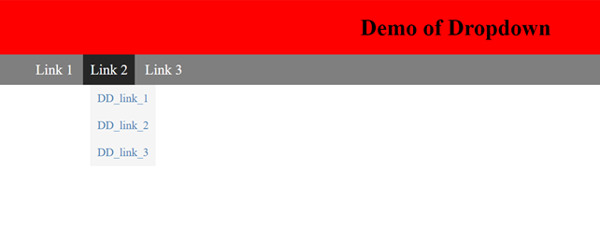

**Problem 2.**

**Create a gmail account creation form to take input from users as specified below. Take the below image as reference.**

* 1. Use background image/video for the page and fix it
  2. On focusing input tags change background color to steal blue with opacity 0.35
  3. Add submit and reset buttons
  4. Add border to the form

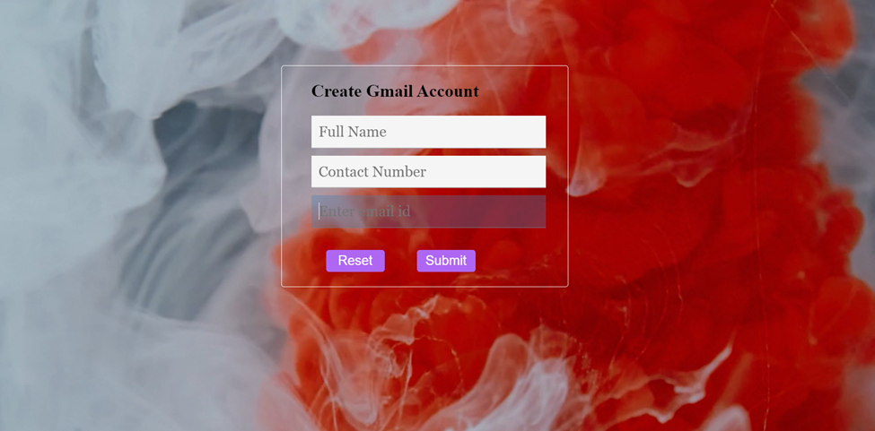

**Problem 3.**

**Create a Navbar with Menu Items**

Home

About

Products

Services

Contact

When each of the Menu Item is selected the respective DropDown should be available

but here at least create one drop down for "Products"

with the options:

Electronics

Cosmetics

Home Appliances

Hardware

Software

**Note: Implement Without Using Descendant selectors like nth child, you can use**

**pseudo class selector like a: hover / link etc**

